**2nd Questionnaire Results**

**Virtual Experience: First Test**

The second questionnaire of the user test aimed at measuring the level of immersion without any physical stimulus.

Regarding the imagery, the results show that the VR environment was realistic and contributed to the immersion. (See Graphic 1 and 2)

In questions 5 to 8 the user was asked about the usability of the controllers. All of the volunteers found it easy to move around and interact with the environment. Nevertheless, the impact of the ease-of-use of the controllers was diverse among the users, ranging from low to very high immersion. (See Graphic 3, 4, 5 and 6)

Finally, questions 3, 4, 9, 10, 11, 12, 13, 14, 15 and 16 measured the sense of being present in the virtual environment.

Half of the users forgot that they were in a laboratory and thought that they were standing on a mountain. The other half didn’t feel as immersed. (See Graphic 7 and 8)

When asked about any physical stimulus, 3 out of 4 agreed that they felt something apart from wearing the headset. Two highlighted the impact of the sound and one the impact of the vibration of the controllers. This had a diverse effect on the immersion, ranging from neutral to very immersed. (See Graphic 9)

Three quarters of the participants never felt like taking their headset off while they were in the experience to see what was happening around them. Besides, one participant felt that he was to some extent separated from the real world, but the other three didn’t felt it that much. Half of them had a stronger sense of being in the virtual world than in the real world and the other half didn’t feel the difference that much. (See Graphics 10 and 11)

The volunteers hardly noticed events taking place around them and neither were they so involved in the experience that they forgot they were using controls. (See Graphic 12 and 13)

Last, but not least, they all felt at some extent disappointed that the experience was over and would like to repeat it. (See Graphic 14 and 15)

**Graphics**

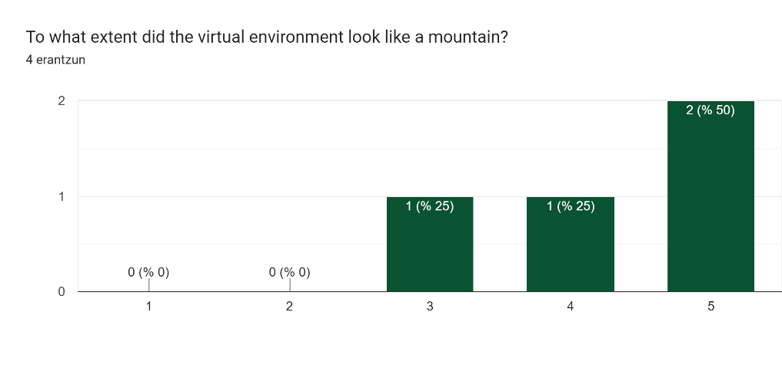

Graphic 1

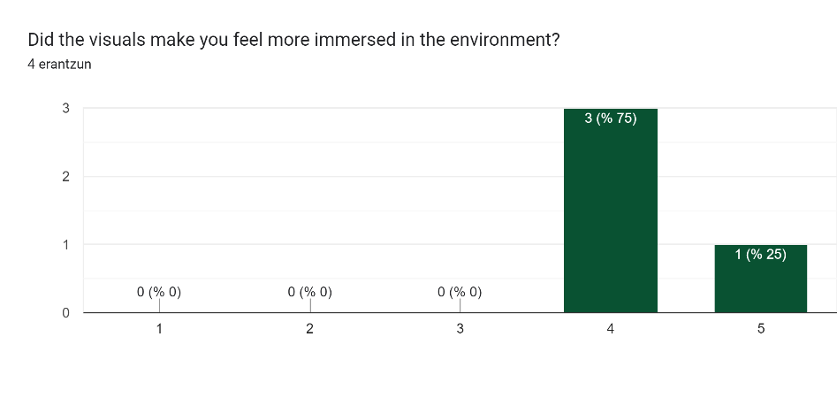

Graphic 2

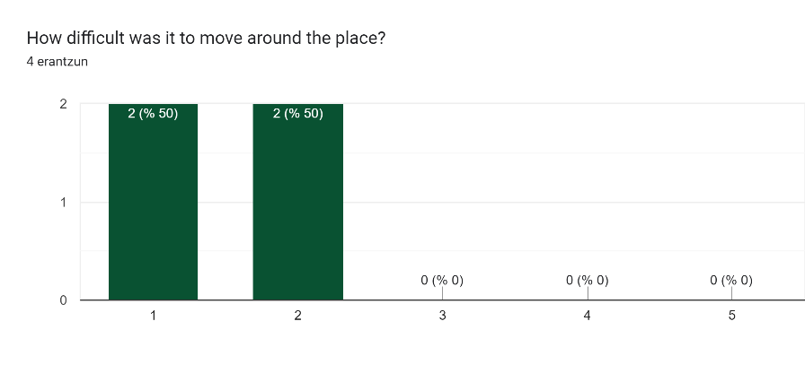

Graphic 3

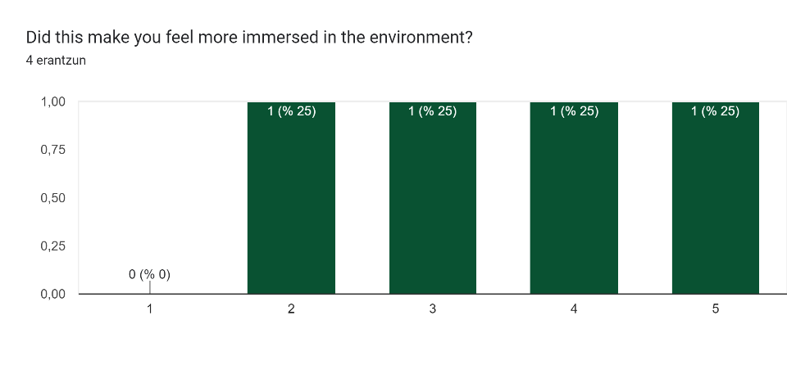

Graphic 4

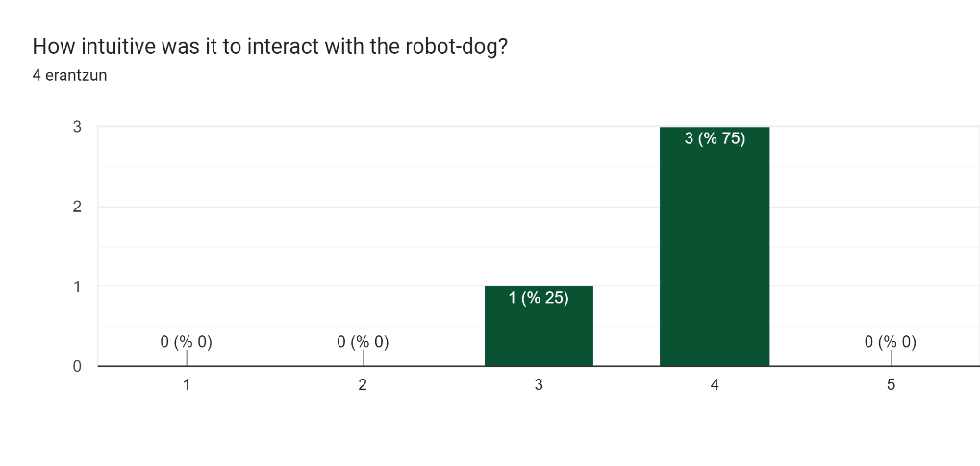

Graphic 5

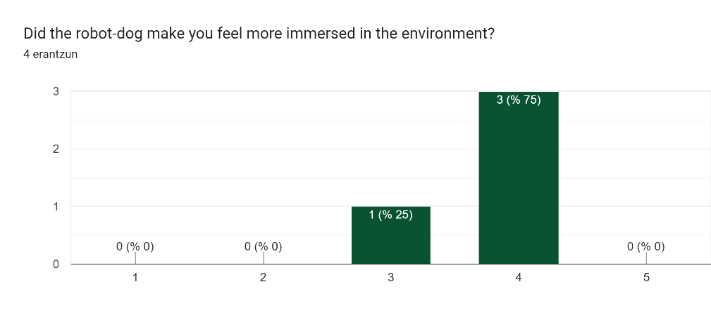

Graphic 6

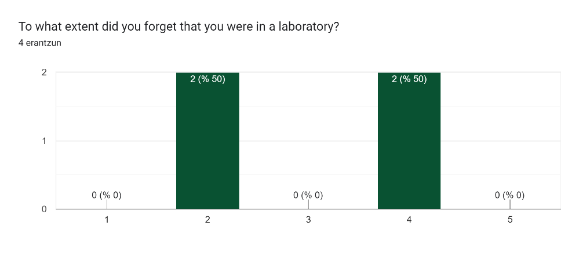

Graphic 7

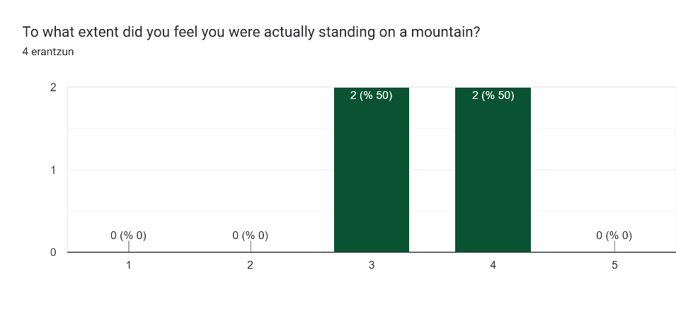

Graphic 8

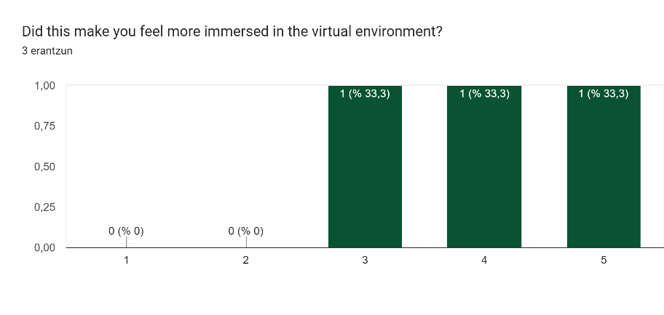

Graphic 9

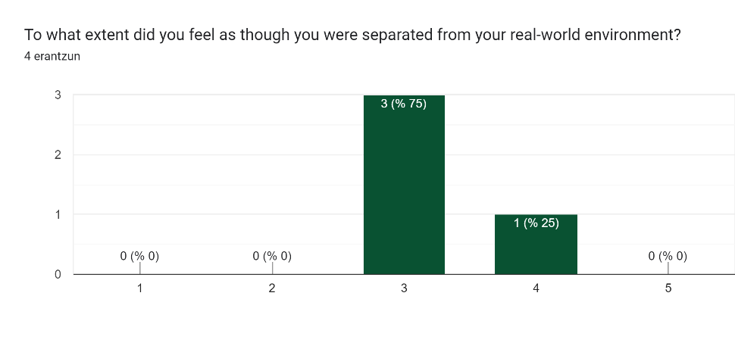

Graphic 10

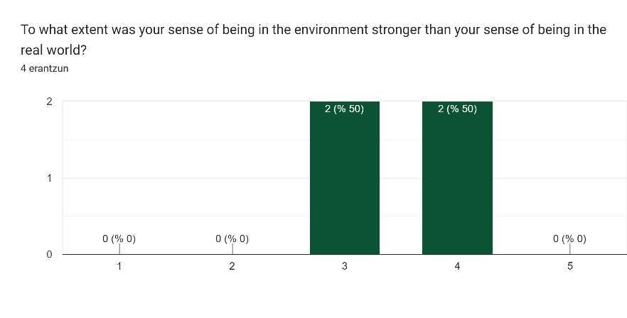

Graphic 11

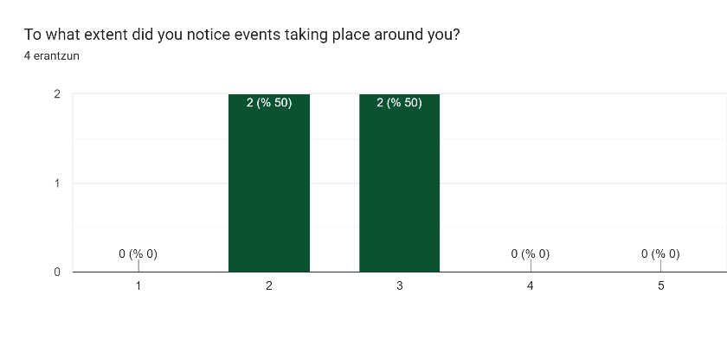

Graphic 12

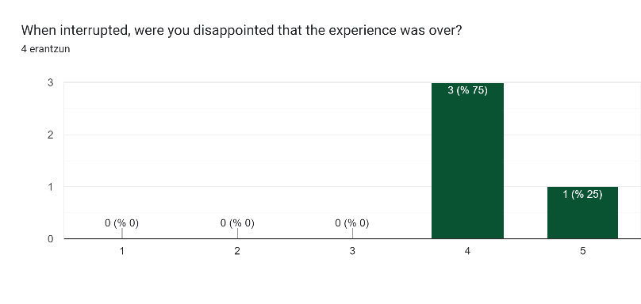

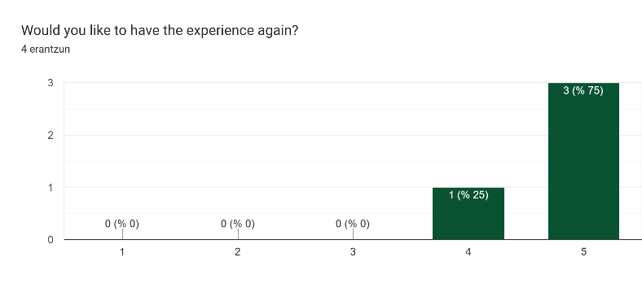

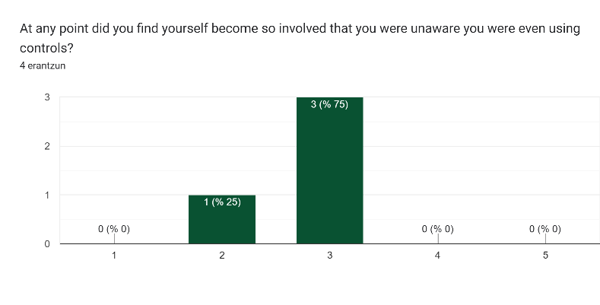

Graphic 15

Graphic 14

Graphic 13